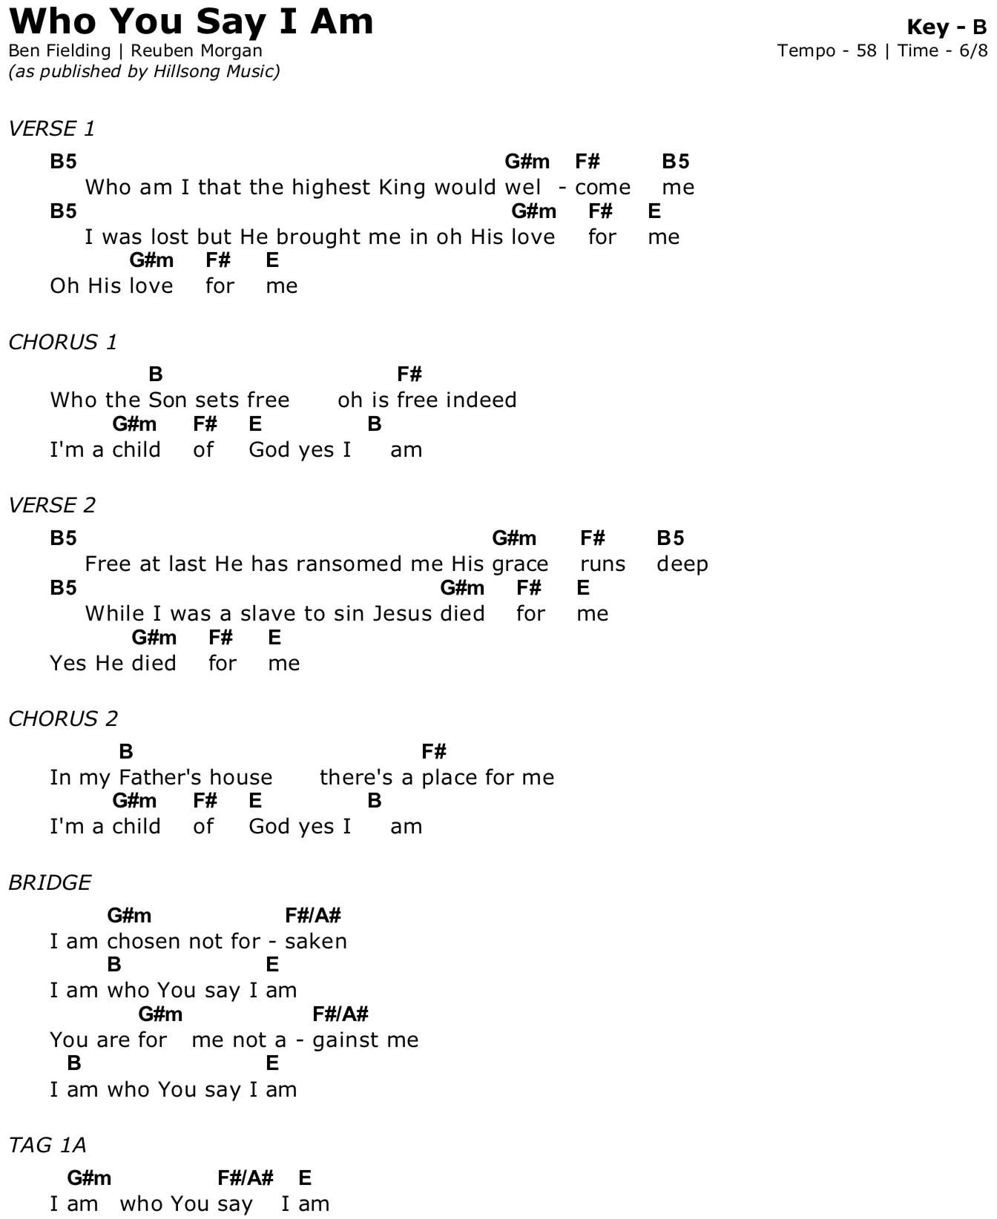
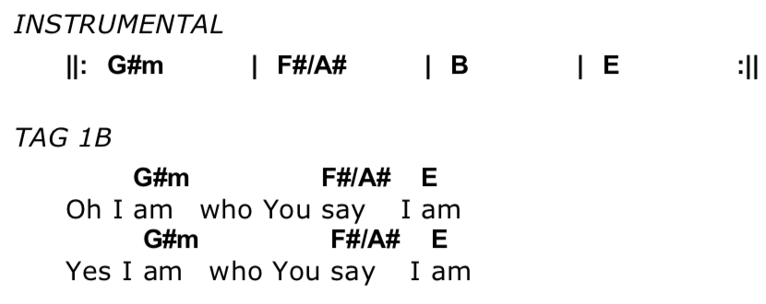
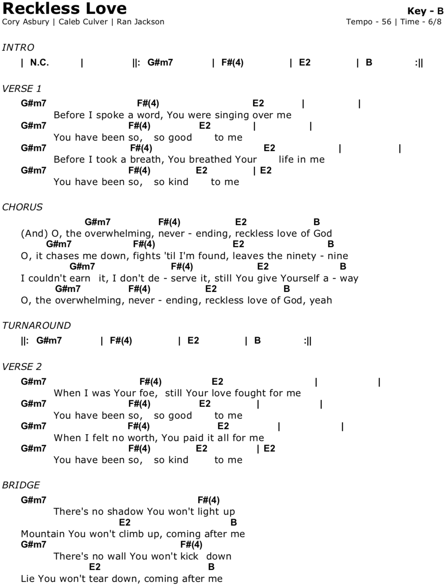

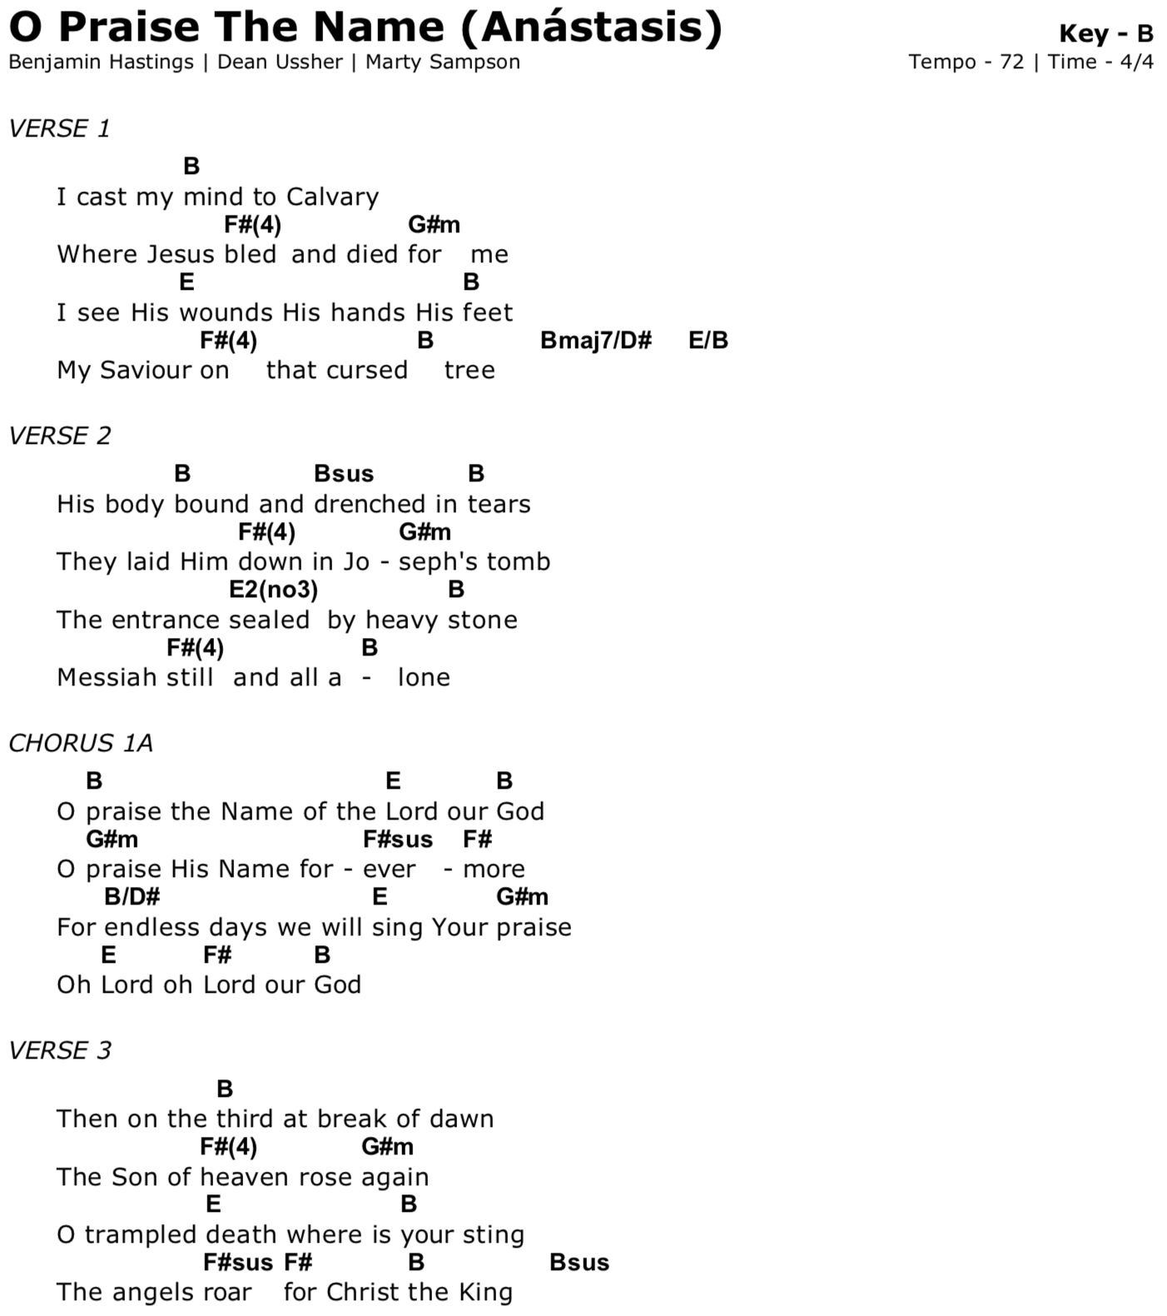
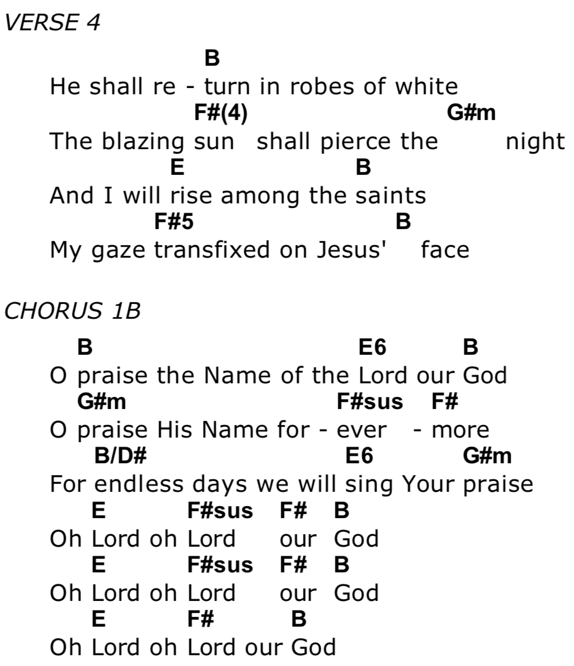

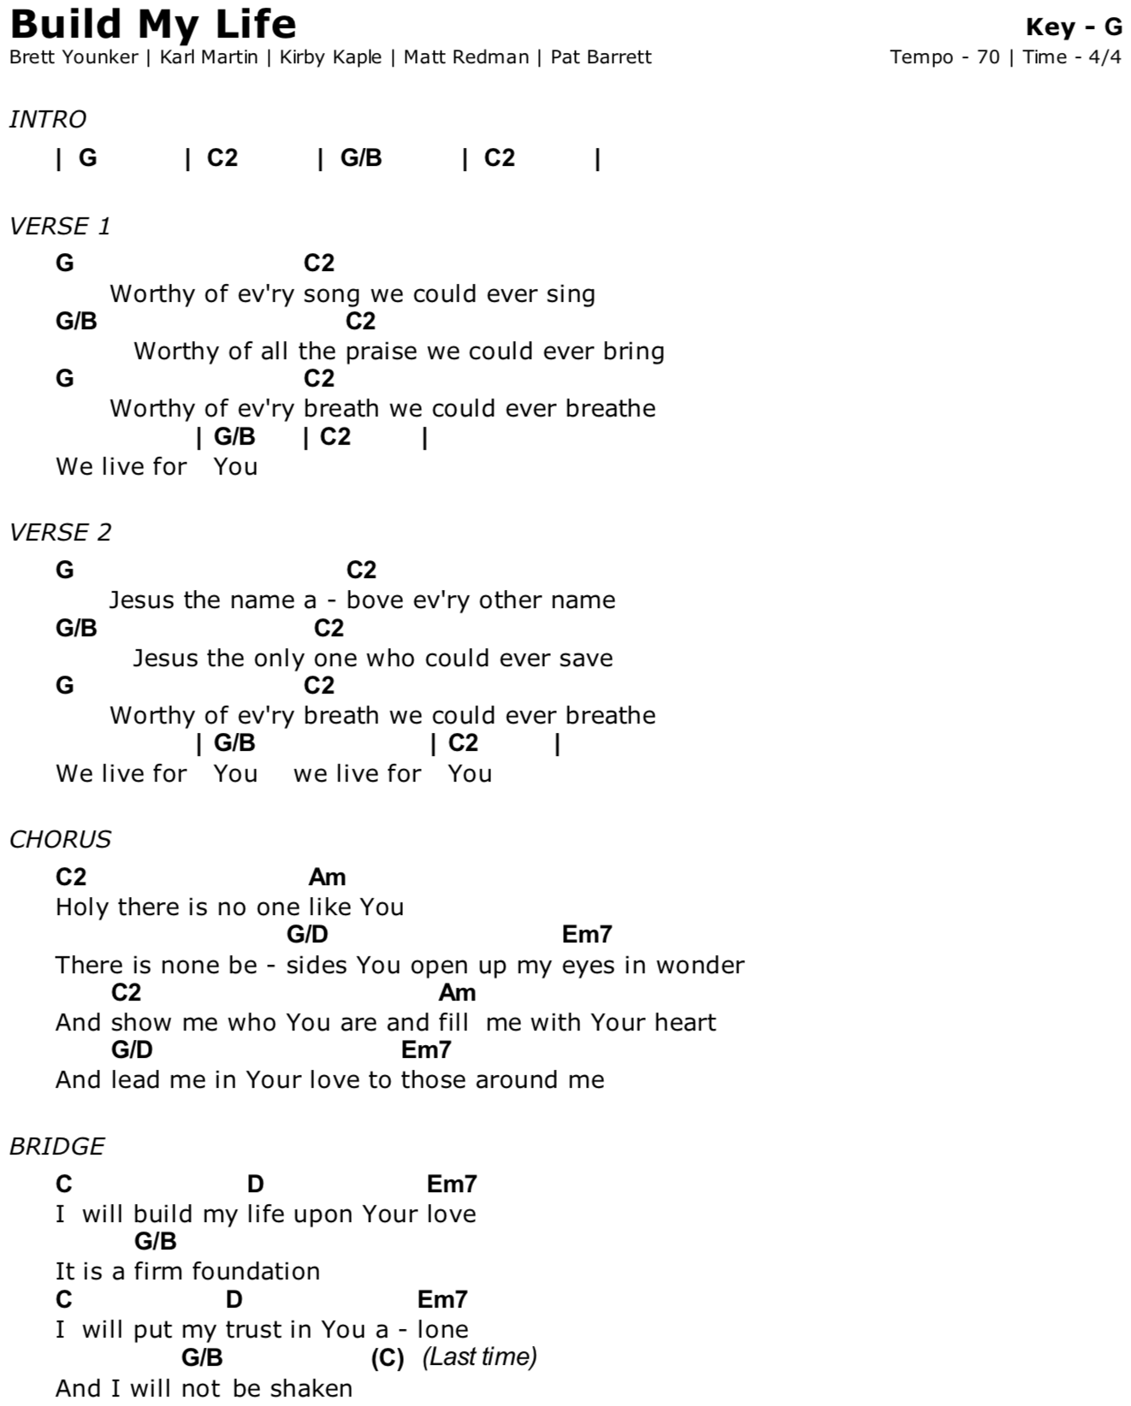
No Longer Slaves

Intro Em D G C

G
You unravel me, with a melody
C D G
You surround me with a song
G
Of deliverance, from my enemies
C D G
Till all my fears are gone

C D G
I’m no longer a slave to fear
Em D G
I am a child of God (Em D G C)

G
From my Mothers womb
Bm
You have chosen me
C D G
Love has called my name
G Bm
I’ve been born again, into your family
C D G
Your blood flows through my veins

Interlude - Em D G C

Em D G C
You split the sea, so I could walk right through it
Em D G C
My fears were drowned in perfect love
Em D G Bm
You rescued me, so I could stand and sing
C D G
I am a child of God

